In your recently published paper in SM, the following equation is used to fit the forward characteristics of Si solar cells,

$$J\left(V,T\right)=-J_{Ph}+\frac{qn_{i}d}{2τ_{g}}\left\{\exp\left[\frac{q\left(V-JR_{s}\right)}{n_{id}kT}\right]-1\right\}+\frac{qn_{i}^{2}}{p_{p}}\sqrt{\frac{μ_{n}kT}{τ_{n}}}\left\{\exp\left[\frac{q\left(V-JR_{s}\right)}{n_{id}kT}\right]-1\right\}+\frac{V-JR_{s}}{R_{sh}} (1)$$

Please note that above equation has the following problem,

In the exponential term of above equation the product JRS has the dimension of Volt/cm2 where as V is in Volt. This means that JRS can’t be subtracted from V. Fitting of the forward J-V characteristics with the above equation is going to yield incorrect results.

Alternatively I have tried to fit the experimental data (I-V characteristics in place of J-V characteristics) received from you with the following equation,

$$I=-I_{Ph}+I_{sat}\left[\exp\left(\frac{qV}{ηkT}\right)-1\right] (2)$$

In the above equation η is the ideality factor. While fitting the forward characteristics the series resistance of the diode is taken care of by using the following expression,

$V_{appl}=V+I{. R}_{s}$ (3)

Where Vappl is the externally applied voltage, V is the voltage across junction and Rs is the series resistance of the diode.

Figure 1 shows dark I-V characteristic of sample t1 at 291K. Circles exhibit the experimental data and continuous line is the theoretical fit by equations (2) and (3). Measured dark characteristics are however not absolutely dark characteristics as the diode current has a finite value at zero bias. The experimental data exhibits a current value of 1.90e-10 Amps at reverse bias voltage of -2.10e-5 volts. By assuming the current value of 1.9e-10 amps as the photocurrent the fit shown in Figure 1 was obtained for an open circuit voltage of 1.5e-6 volts.

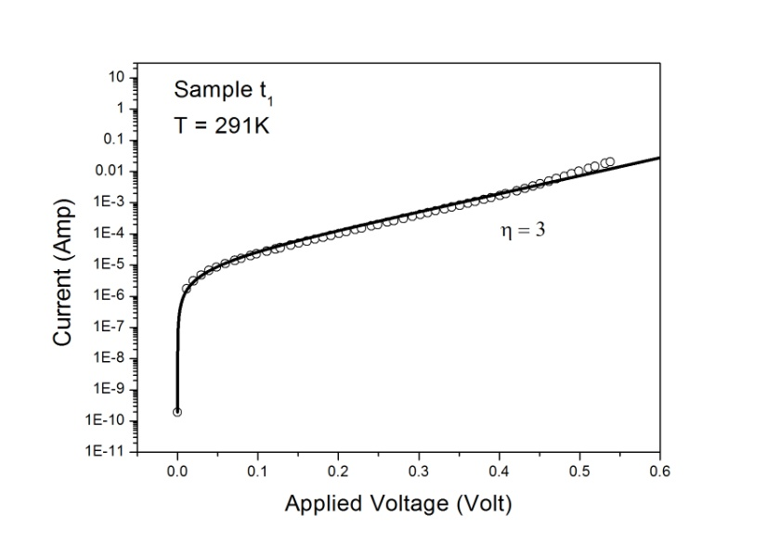 Figure 1: Forward I-V of sample t1.

The results obtained for sample S1 are shown in Figure 2. These illuminated I-V characteristics were measured at 291K under low illumination of 600 nm monochromatic radiation. Circles exhibit the measured data and continuous lines correspond to theoretical fit using equations (2) and (3). The measured current of 1.713e-5 amps at -5.4e-5 volt was assumed as the photocurrent of the diode. The continuous line fit as shown in Figure 2 was obtained for a VOC of 8.1e-2 volt and ideality factor of 3.

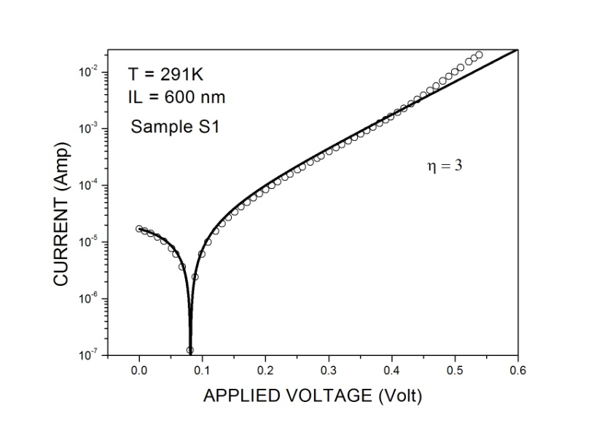Figure 2: Forward I-V of sample S1.

Figure 3 shows similar results for sample L1. The measured illuminated forward I-V at 291K under low illumination of 900 nm monochromatic radiation are shown by points (circles) in Figure 3. Continuous lines exhibit the theoretical fit of the measured data by equations (2) and (3). The measured current of 1.893e-4 amps at -4.30e-4 volts was assumed as the photocurrent of the diode. The continuous line fit shown in Figure 3 was obtained for a VOC of 2.42e-1 volt and ideality factor of 3.

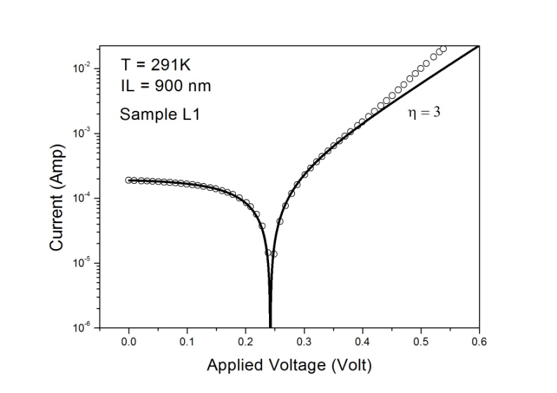Figure 3: Forward I-V of sample L1

Similar kind of fitting between the experimental data and theory is obtained for higher temperatures as well.

The purpose of the above write up is to point out the problem in using equation (1) to fit the experimental forward I-V characteristics of solar cells in your paper. In addition my analysis of the data show that the experimental data provided by you can be fitted with a much simpler combination of equations (2) and (3). I have also noted that the shunt resistance of these solar cells is around 3000 to 6000 ohms. This kind of low shunt resistance may be due to the presence of high surface leakage currents that is responsible for the high ideality factor of 3 of the Si diode in the present case. Our gate controlled diode experiment in HgCdTe has already shown (J. Appl. Phys. 120: 8, 084508 (2016)) the dependence of ideality factor on surface leakage currents.